**Target User Community:**

1. **College Students (Primary Focus)** –

Students often need textbooks for different courses and semesters. This platform allows them to exchange books affordably instead of buying new ones.

2. **General Book Enthusiasts** –

People who love reading and collecting books can use the platform to discover and exchange books with like-minded individuals.

3. **Educators and Researchers** –

Professors, teachers, and researchers looking for reference materials can use the platform to acquire books relevant to their academic or research needs.

4. **Budget-Conscious Readers** –

Individuals who prefer exchanging books instead of purchasing new ones to save costs while still enjoying access to a variety of books.

**Flowchart:**

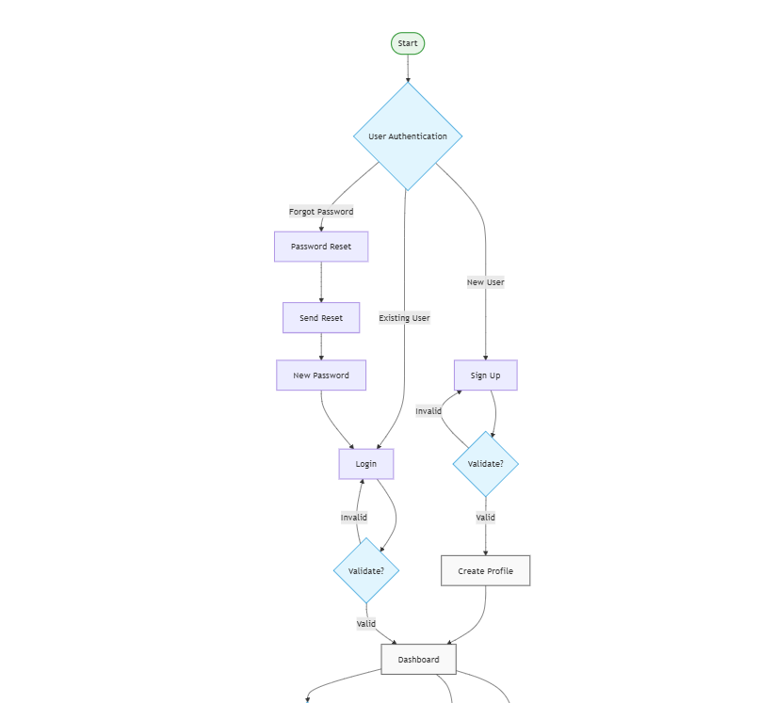

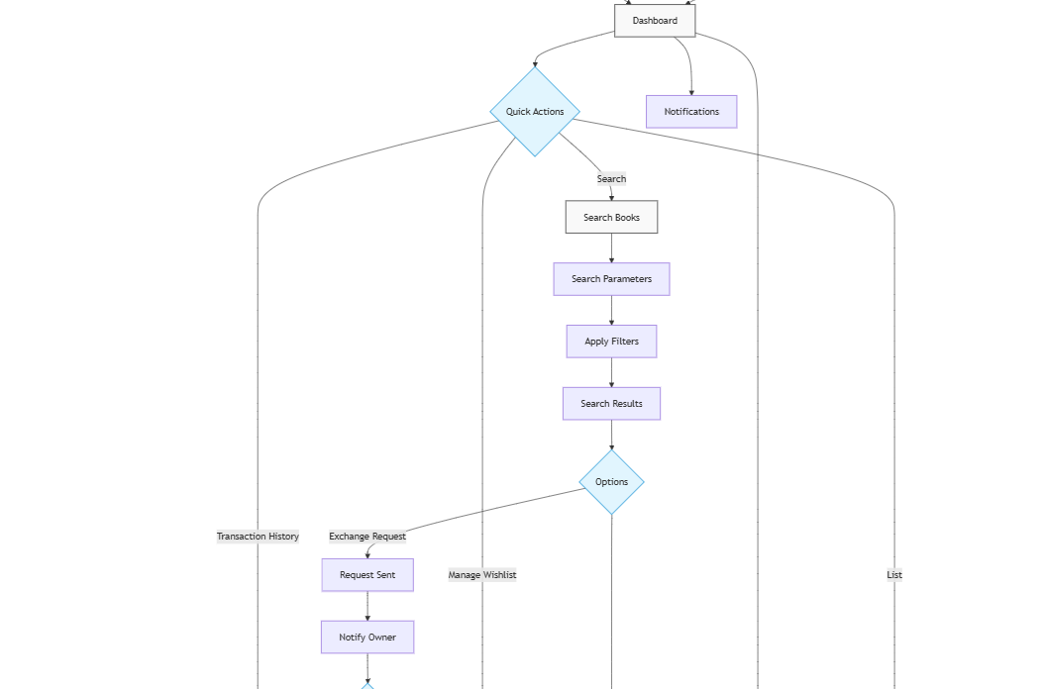

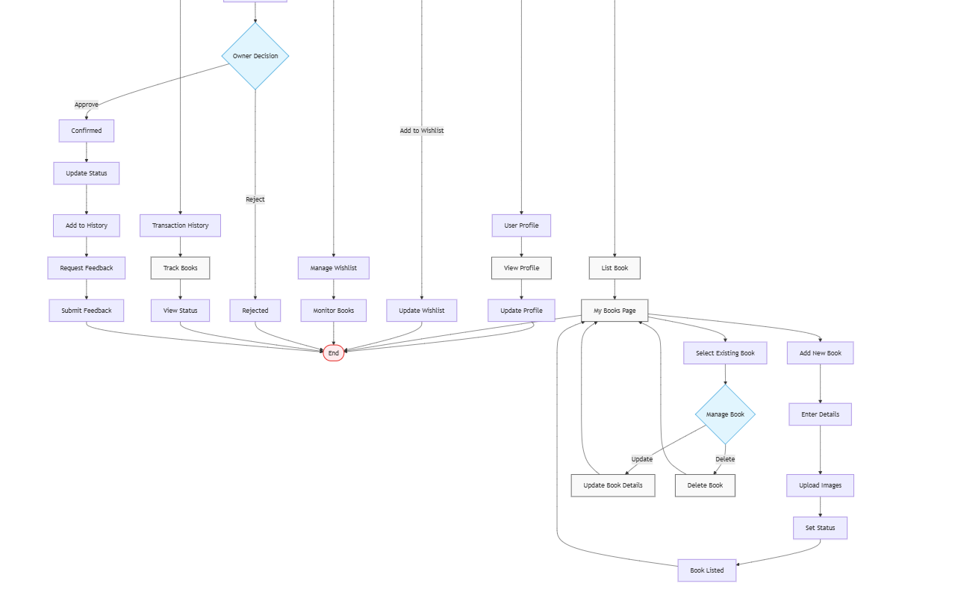

**SCREENSHOTS:**

**Login Page:**

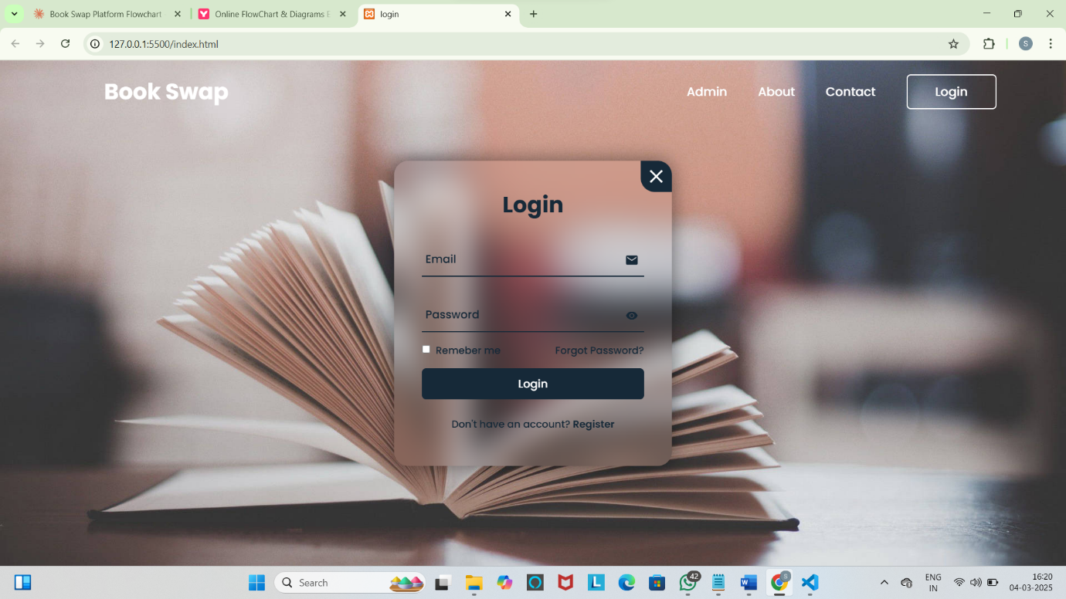

**Forgot Password:**

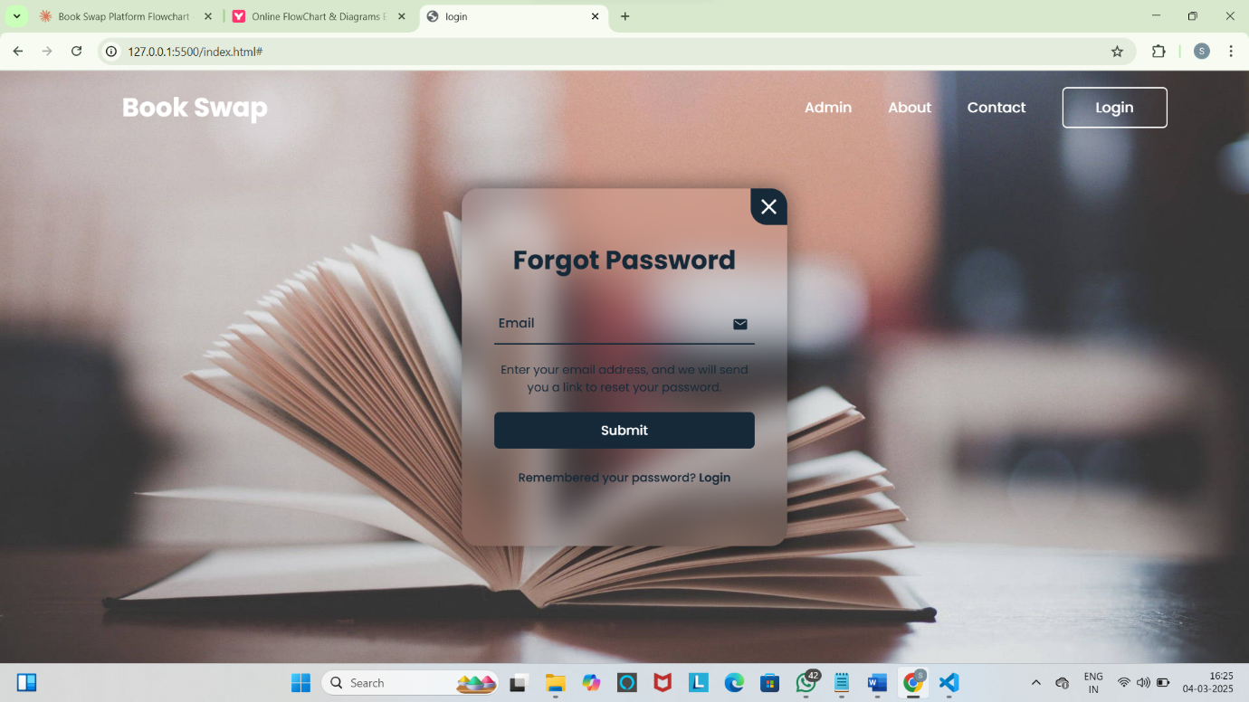

**Registration Page:**

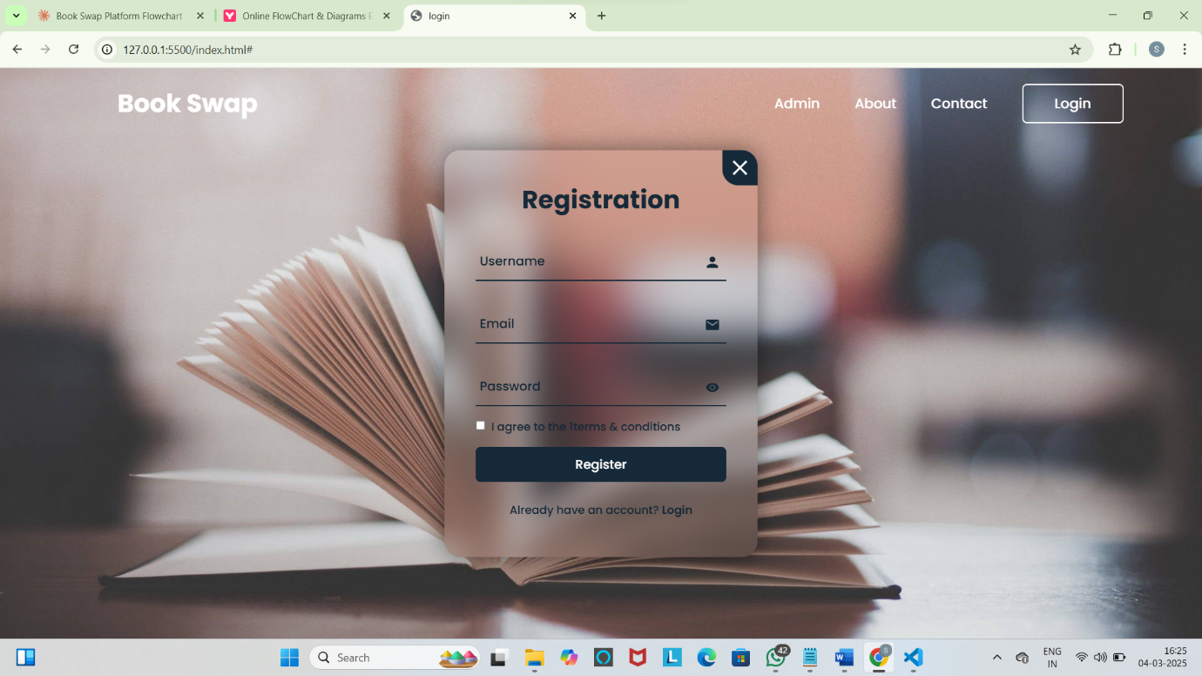

**Dashboard Page:**

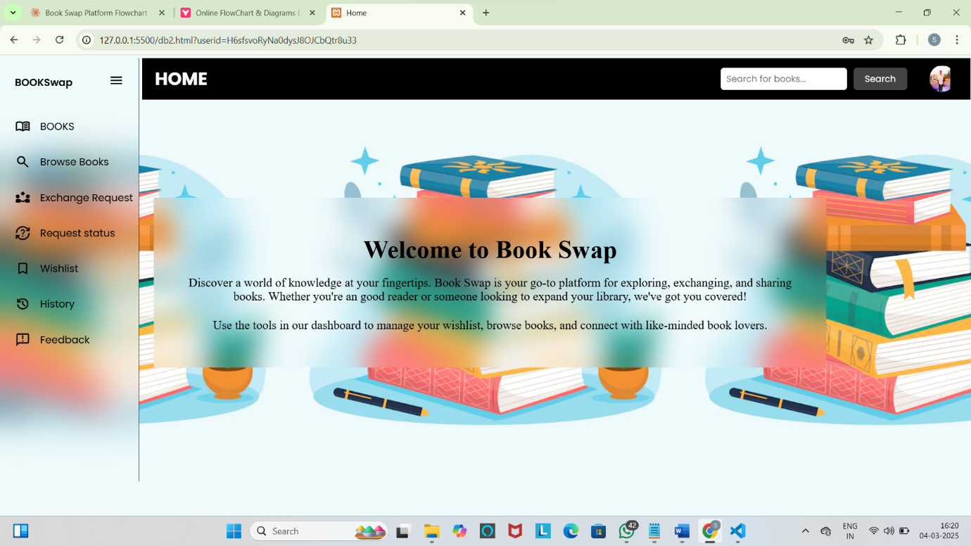

**ViewBooks Page:**

The user sees the book that they uploaded in the platform and the user can Add new books, or update and delete books.

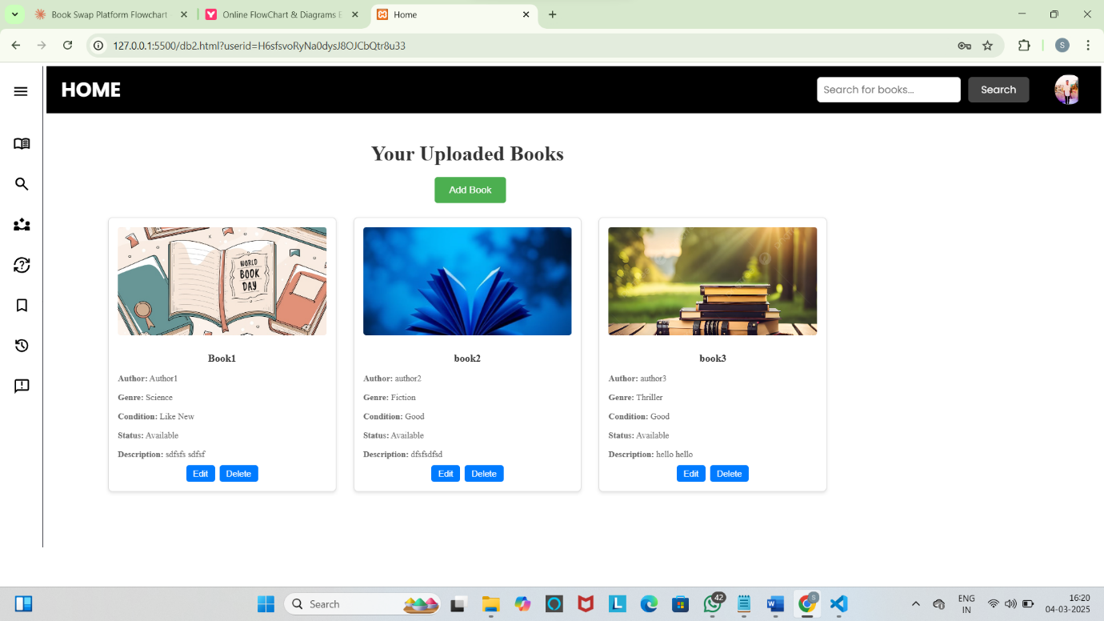

**AddBooks Page:**

The page where user can add new books by entering the details and images of the book.

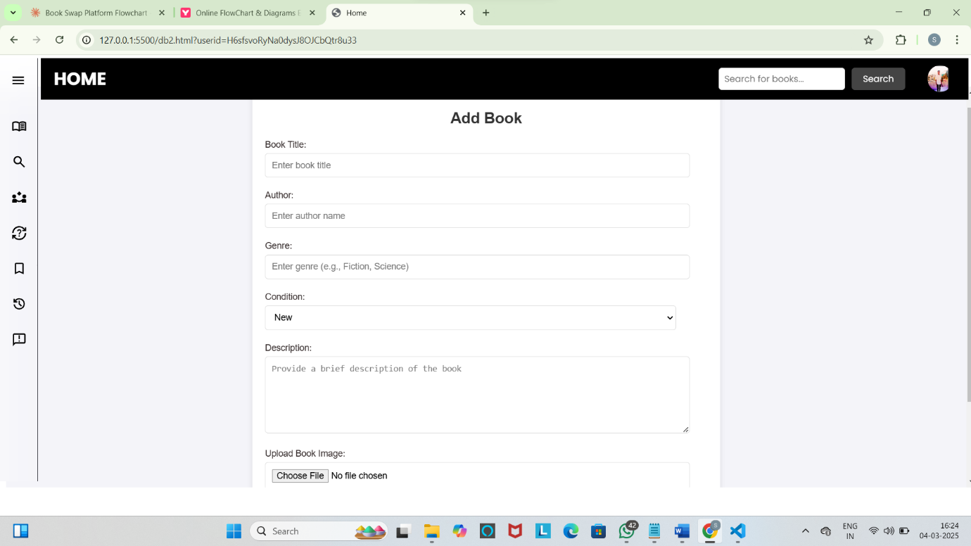

Like this AddBooks page… UpdateBooks page, where the details of the books are fetched from the firebase then user can edit the details.

**BrowseBooks Page:**

The page where user can browse books that are available in the platform, and there user had three functions like view more details, add to Wishlist, and give exchange request for the books.

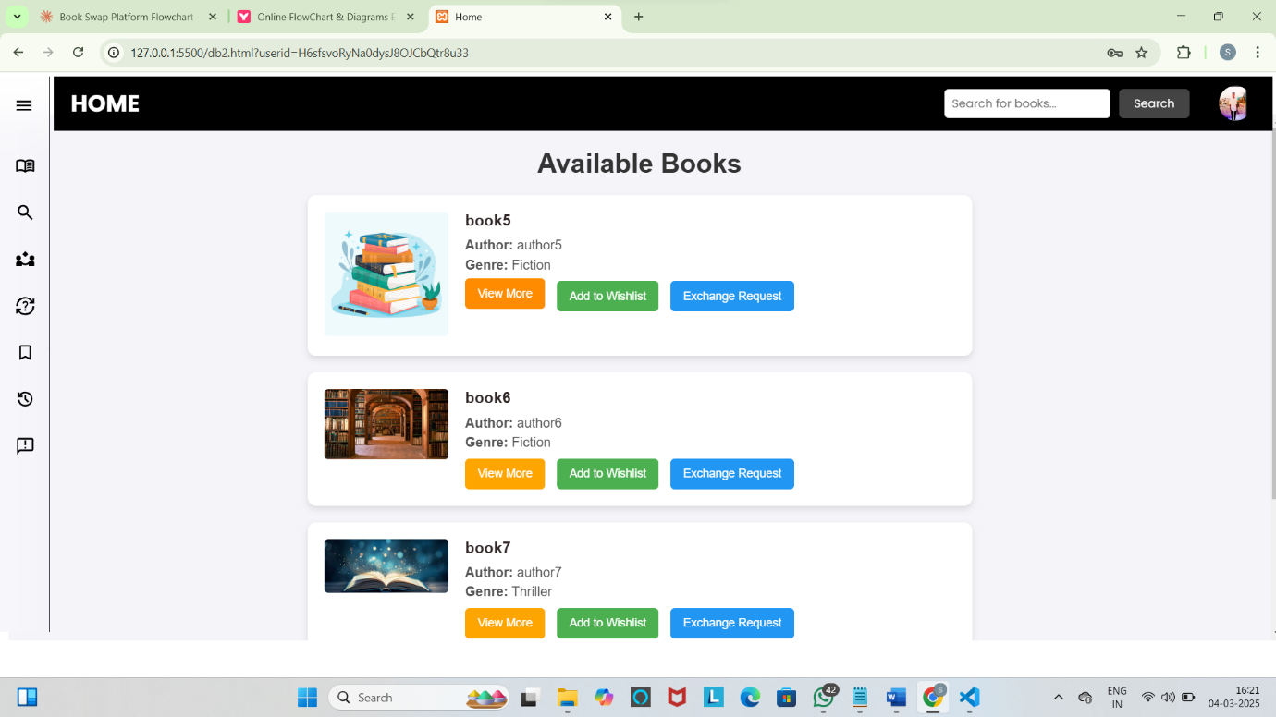

**POPUP BOX:**

When user click view more button for the books shows all the details of the book.

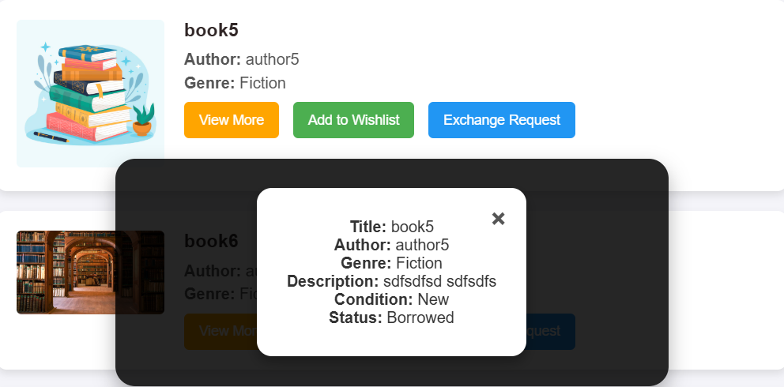

**Exchange Request Page:**

The page will show what are the request that the user had for exchange. The user can decides to accepts or rejects the request.

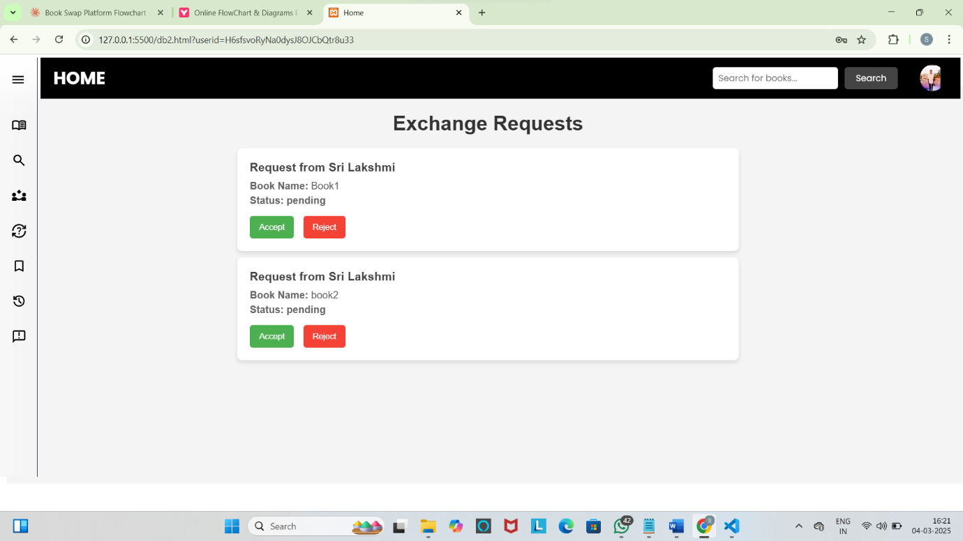

**Request Status page:**

The page where user can see the status for the request they give for exchanging books.

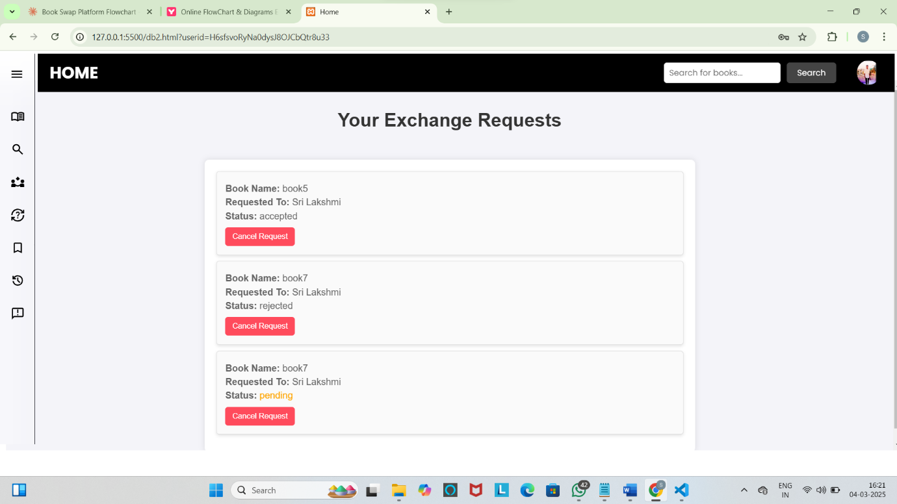

**Profile page:**

User can edit the profile.

